SETTING UP APPLICATION ENVIRONMENT

**INSTALL IBM CLOUD CLI**

|  |  |
| --- | --- |
| Date | 1 Nov 2022 |
| Team ID | PNT2022TMID18036 |
| Project Name | Smart Fashion Recommender Application |
| Team Members: | Ramyadevi RS  Samyuktha V  Srija J  Subiksha R |

# Step 1: Login to your IBM Cloud [*https://cloud.ibm.com/login*](https://cloud.ibm.com/login) and in-search bar you can type Container registry and click to get started.

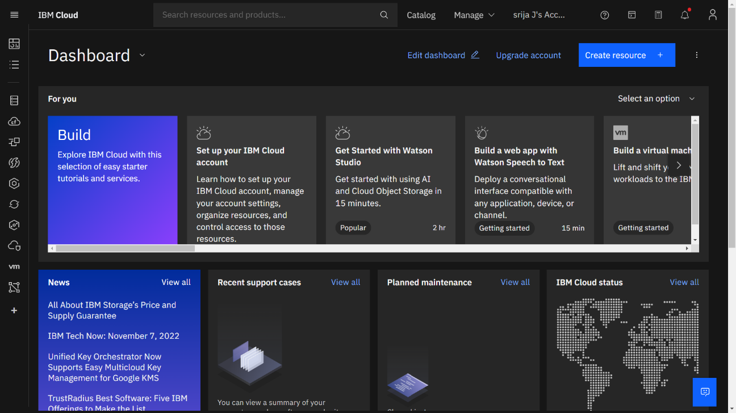

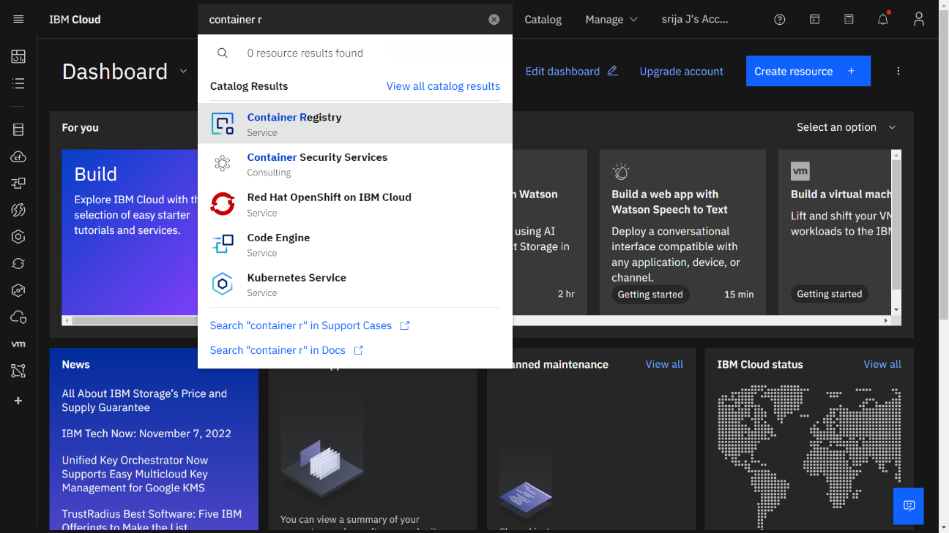

# Step 2: Follow and do the step given in this page one by one

# [*https://cloud.ibm.com/registry/*](https://cloud.ibm.com/registry/)[start](https://cloud.ibm.com/registry/%20start)

# Step 3 : Run the command in power shell, (New-Object Net.WebClient).DownloadString('https://clis.cloud.ibm.com/install/powershell')

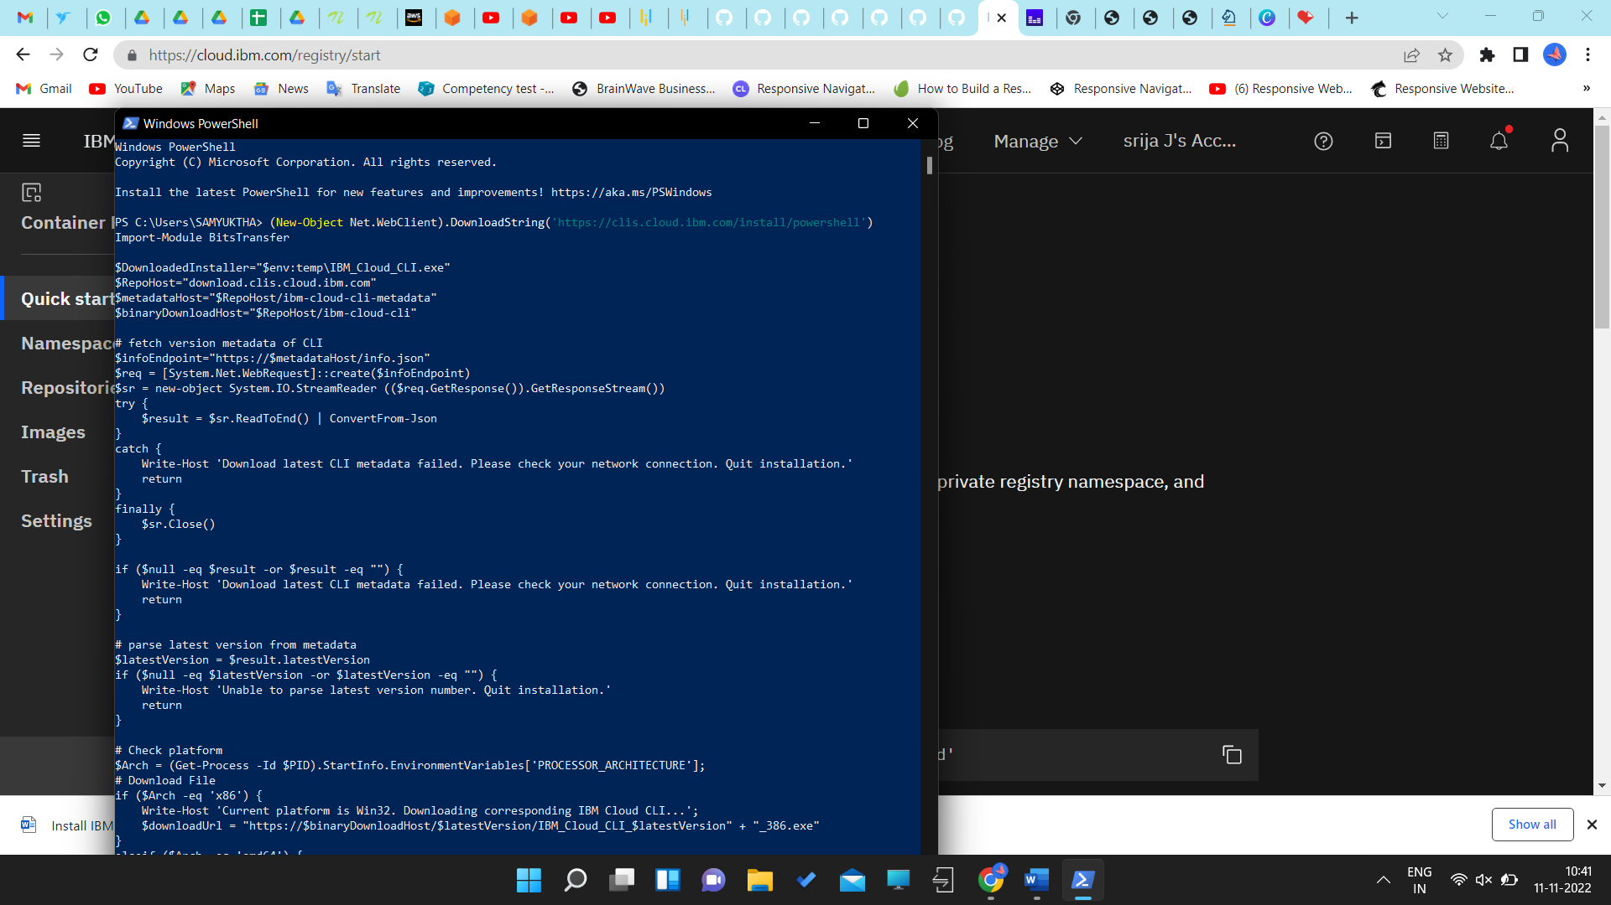

# 

# Step 4: Enter the command in cmd:

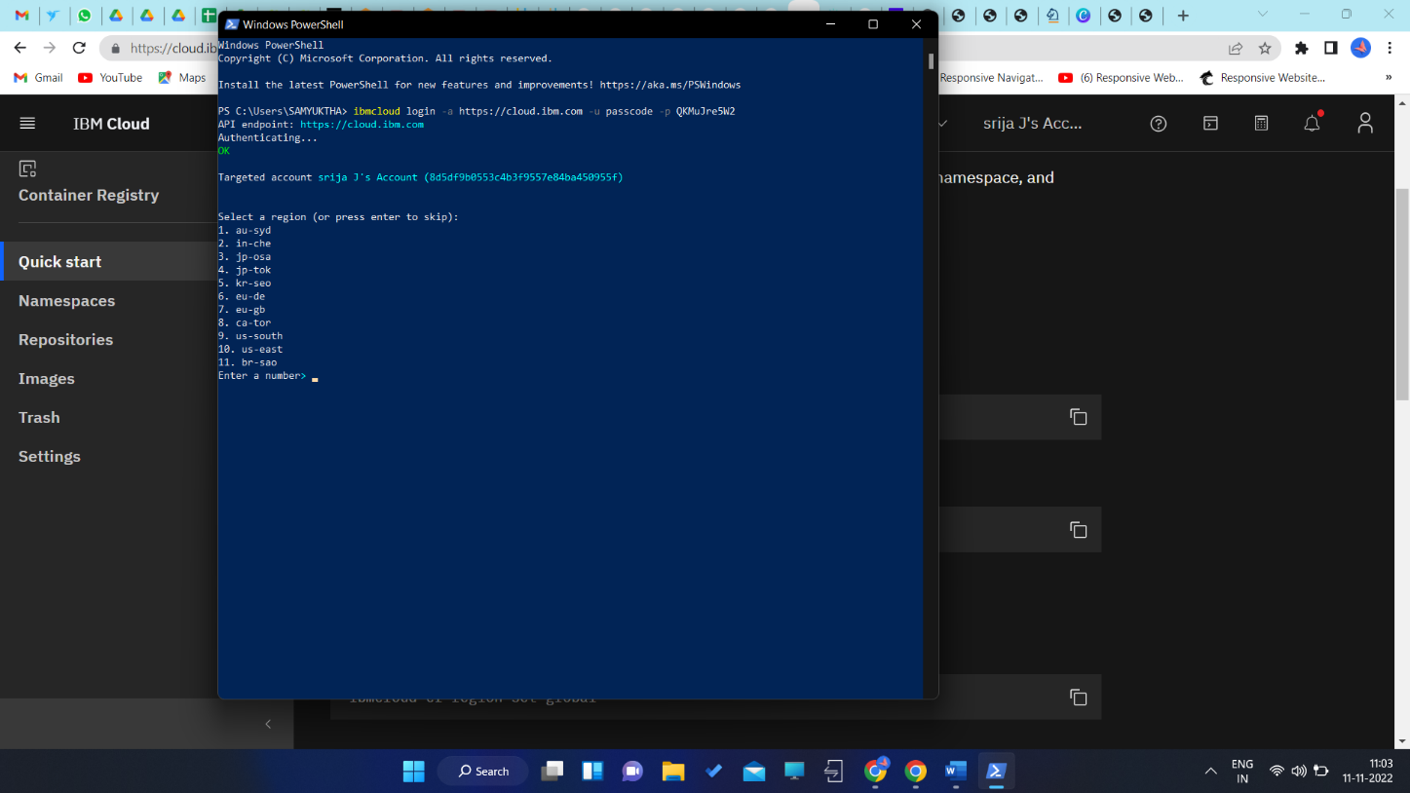

# Step5:

Run all the command one by one in cmd <https://cloud.ibm.com/docs/containers?topic=containers-cs_cli_install>

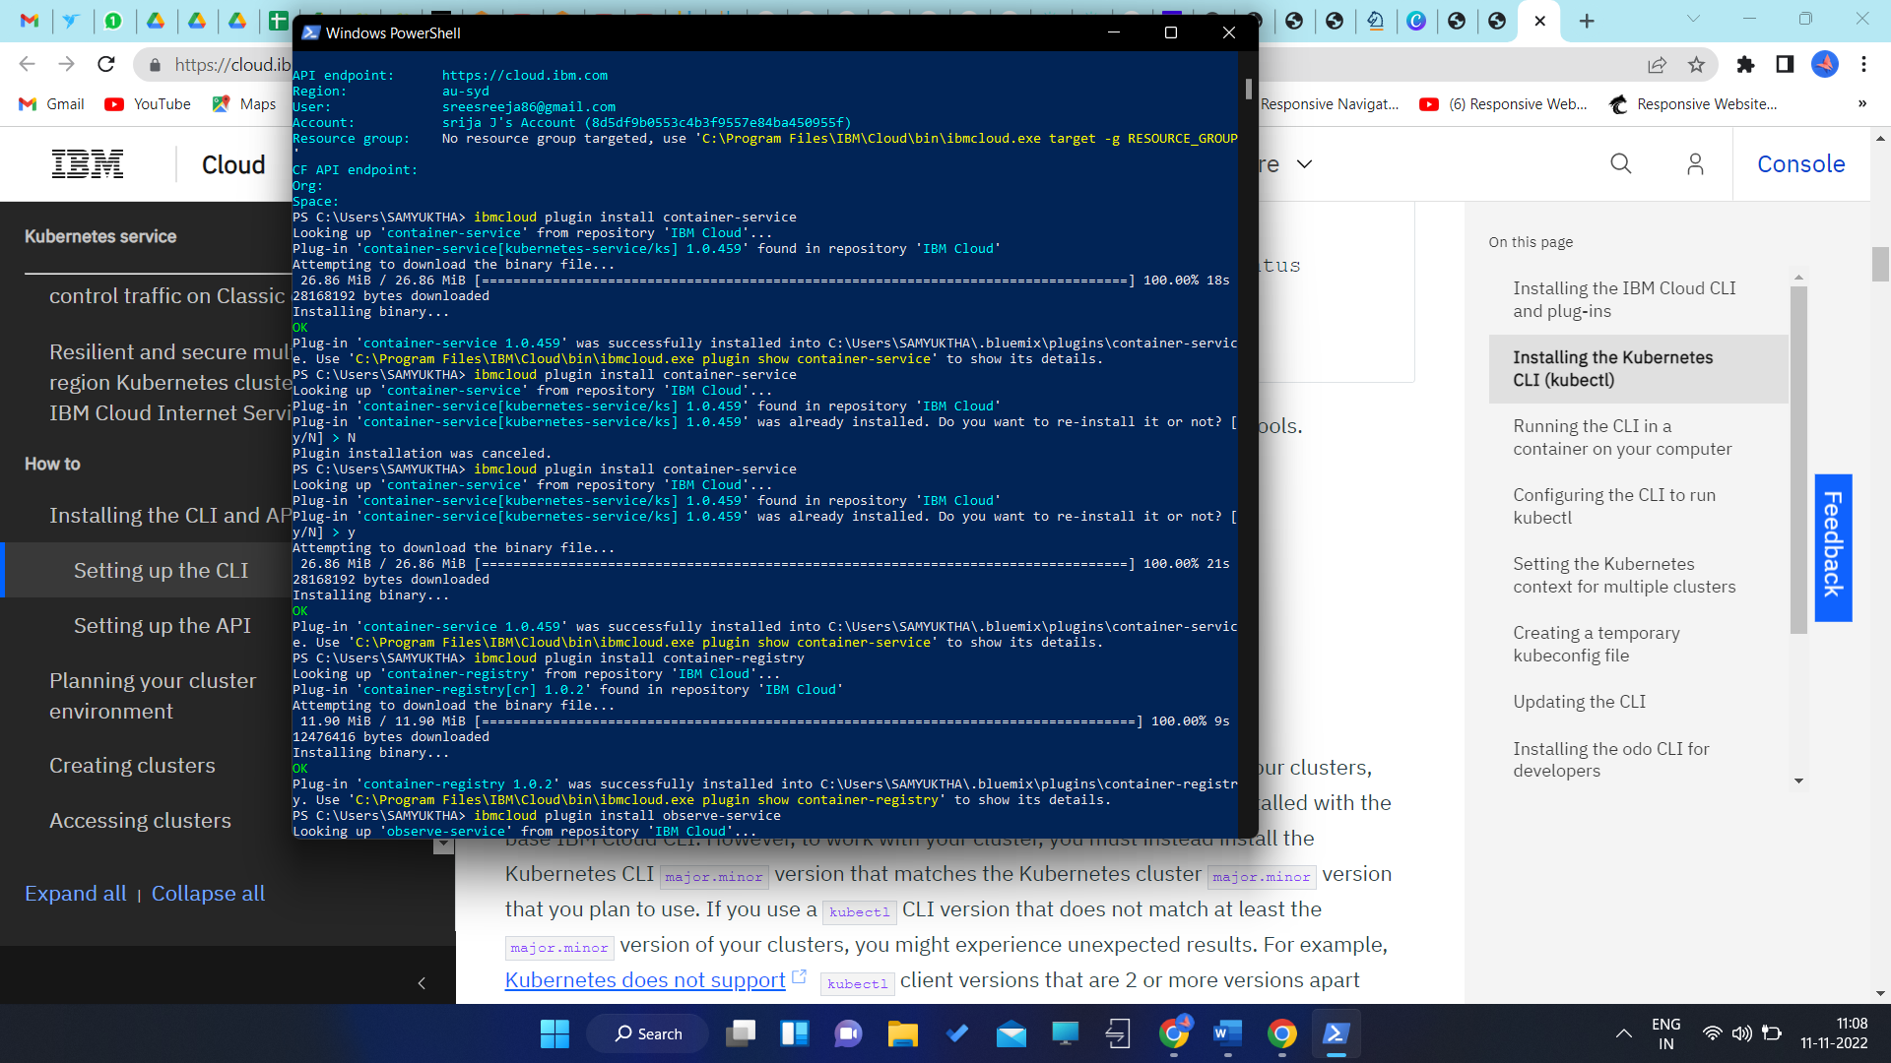

# Step 6:

Finally, you will get the IBM CLOUD CLI in your desktop